**Proposal on**

**FIN**

(Friend In Need)

**Prepared** **for**

**Dr. -Ing. Nusrat Jahan Lisa, Assistant Professor**

**A. K. M. Ahsanul Hoque, Adjunct Professor**

**Prepared by**

**Lab Section: B2**

**Kh. Rifat Amin, 180204116**

**Fazlay Elahi Safin, 180204119**

**Sanjida Aziz Tonny, 180204122**

**Md Zahidul Haque, 180204136**

**S.M Tasnimul Hasan, 180204142**

**Date: 04/01/2022**



**Ahsanullah University of Science and Technology**

**Department of Computer Science and Engineering**

**Executive Summary**

FIN App is basically an emergency application for mass people. Through this app users will get help in various kind of emergency situations.

There are lot of people who face problems in finding blood donors when needed. Sometimes blood banks are out of blood. They have to contact with lot of people then. Even though there are lot of people around us who donates blood, we can’t find their information when needed.

Another kind of emergency situation we face to find locations. When people go to any new area, they have no idea about that place. Sometimes people get lost, or may face any kind of dangerous situation. They might need to reach people immediately or need to reach nearby help station.

We need a friend who can help us whenever we need. We may face this kind of difficulty in our everyday life. But people are busy with their own life. How can anyone be standby with a person! So, we came up with a solution. Every person of these days carries phone with them. So, we are building an android app which can help a person like a “Friend In Need”.

**Table of Contents**

|  |  |
| --- | --- |
| **Contents** | **Page no** |
| 1. **Letter of Transmittal** | 03 |
| 1. **Introduction** | 04 |
| * 1. **Project Introduction**   2. **Team Introduction** |  |
| 1. **Background of the Study** | 04 |
| * 1. **Project background** |  |
| 1. **Objectives**    1. **Primary Objective**    2. **Secondary Objective** | 05 |
| 1. **Methodology** | 05 |
| * 1. **Process Model** |  |
| 1. **The Project** |  |
| * 1. **Communication** | 07 |
| * 1. **Planning** | 09 |
| * 1. **Modeling** | 11 |
| * 1. **Construction** | 12 |
| * 1. **Conclusion** | 12 |
| * 1. **Bibliography/References:** | 12 |
| **Appendix** | 13 |

**Letter of Transmittal**

January 4, 2022

A. K. M. Ahsanul Hoque

Assistant professor

Ahsanullah University of Science and Technology

Tejgaon Industrial Area, Dhaka

**Subject: Submission of project proposal on android app FIN**

Sir,

We are submitting herewith our project proposal entitled ‘FIN’ as partial fulfillment of the CSE 3224 course requirements.

This project proposal details our android app description, project background, objectives, working process method, client communication, work plan, estimation, feasibility analysis, project modeling, construction requirements and so on.

We hope that this proposal will thoroughly reflect our project plan. If you have any additional questions that you want to ask, feel free to contact us anytime. Please review the report and let us know your thoughts.

Sincerely,

Kh. Rifat Amin, ID: 180204116

Fazlay Elahi Safin, ID: 180204119

Sanjida Aziz Tonny, ID: 180204122

Md Zahidul Haque, ID: 180204136

1. M. Tasnimul Hasan, ID: 180204142

**Introduction**

1. **Project Introduction:**

This app is to provide Emergency services, which helps a person to find a Hospital, Police Station, Pharmacy, ATM Booth and Filling Stations nearest to his location. In this location-based system, our app will use GPS to detect the person’s live location. Person can send his/her current location to anyone via SMS by one tap. Even if he doesn't have an active internet connection then a SOS number will be just one click away. A person can log in to get more features. Through this app person can find blood donor according to his/her need. All over this is a project for a person’s emergency and need.

1. **Team Introduction:**

Project “FIN” will be done by a team of 5 members. In our team ‘S.M. Tasnimul Hasan’ will handle Front end. Back-end works will be done by ‘Md Zahidul Haque’ and ‘Sanjida Aziz Tonny’. ‘Kh Rifat Amin’ and ‘Fazlay Elahi Safin’ will handle networking, communication, business and marketing parts.

**Background of the Study**

**Project Background:**

Every day we open newspaper or TV channel or social media, we see news of accidents, rape, murder, snatching, theft etc. During pandemic situation this kind of tragedy has become very common. Different reasons are behind these incidents. Unfortunately, in our country, safety issues are very disregarded.

Some of these tragic scenarios may needed help. Maybe victims could survive if they could get that help. Thinking of mass people’s safety, we have chosen this project which can help people and they can suffer less.

**Objectives**

1. **Primary Objective:**

In our busy life every person has to go out. People go to different places. Whether the place is unknown or known people may face difficulty or fall to any emergency situation.

Emergency situations can arise at anytime and anywhere. Usually, we seek helps from our friends, family, relatives. But in our busy life how can anyone be able to do help every time needed. People wish to have a friend who can help whenever he/she need. So, to accomplish people’s demand we’ve decided to create an app which can help in our needed time and emergency situations.

1. **Secondary Objectives:**

We wanted to build an app where all the necessary information for emergency situation can be found in one place. And people can be able to use all of these features easily. Thus, life can become easier and safer to live.

**Methodology**

**Process Model:**

A process is a collection of activities, actions and tasks that are performed when some work product is to be created. It enables the people doing the work to pick and choose the appropriate set of work actions and tasks... Software development process defines which member of the development team is doing which part, the timing in relation to other activities and the details and steps in the activity. Communication, planning, modeling, constructions, deployment these are the basic phase of process. All of these phases together called process model. There are different types of process models based on the sequence and intercommunication between these phases. Ex: Traditional process models, Agile Models, The unified process etc.

In traditional process models, the flow of development is unidirectional, from communication to clients and then to planning and development, then to testing and maintenance. This model is based on pre-organized phases of the software development life cycle. Some traditional models are:

1. Waterfall Model
2. Incremental Model
3. Prototyping Model

4. Spiral Model

In this project we will use a Traditional process Models and that is **Incremental** Model. In this model-

- Multiple independent deliveries are identified.

- Within an increment, work flow is linear within an increment and is staggered between increments.

- focuses on an operational product with each increment

- Iterative in nature.

- Provides a needed set of functionalities sooner while delivering optional

components later

- Useful when staffing is too short for a full-scale development and when requirements are well understood.

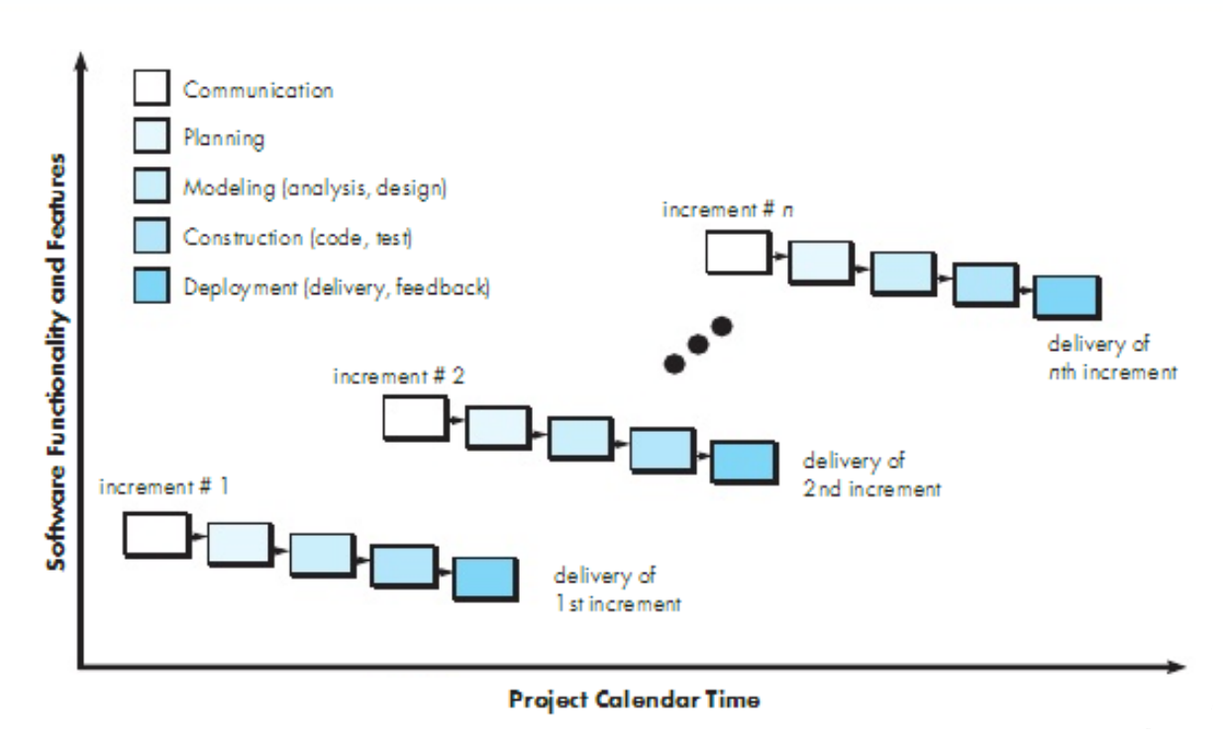

**Figure: Incremental Model**

In our project, work will be divided into some modules. Each module will be done independently by different team members. These individual work modules will perform all phases of process separately. As our project requirements has been well understood and identified this process model will be useful for us. So, we have chosen incremental process model for our project.

**The Project**

1. **Communication**

**Survey**

To have a better understanding of how “FIN” appears to its target audience, as well as what they think about the current situation. The poll was conducted via social media. The results of our poll are listed below.

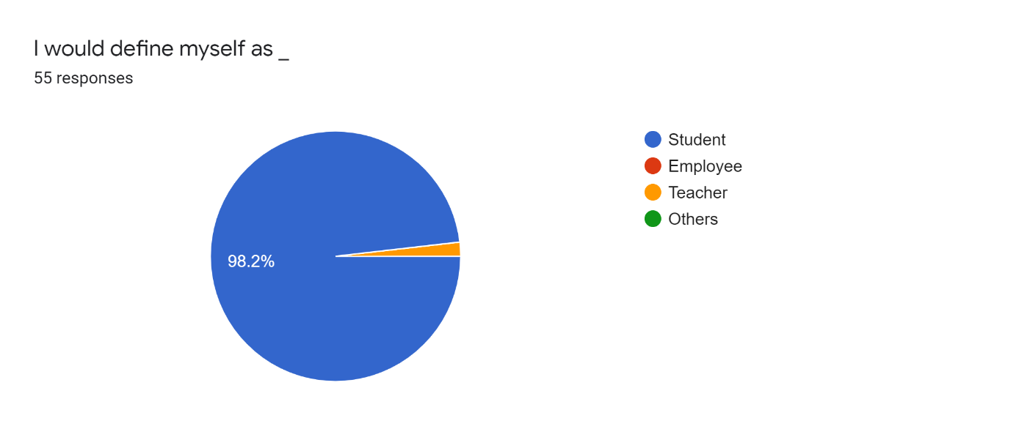

We're attempting to determine which aspects of our website are of interest to visitors. This website appears to be of interest to students and teachers alike.

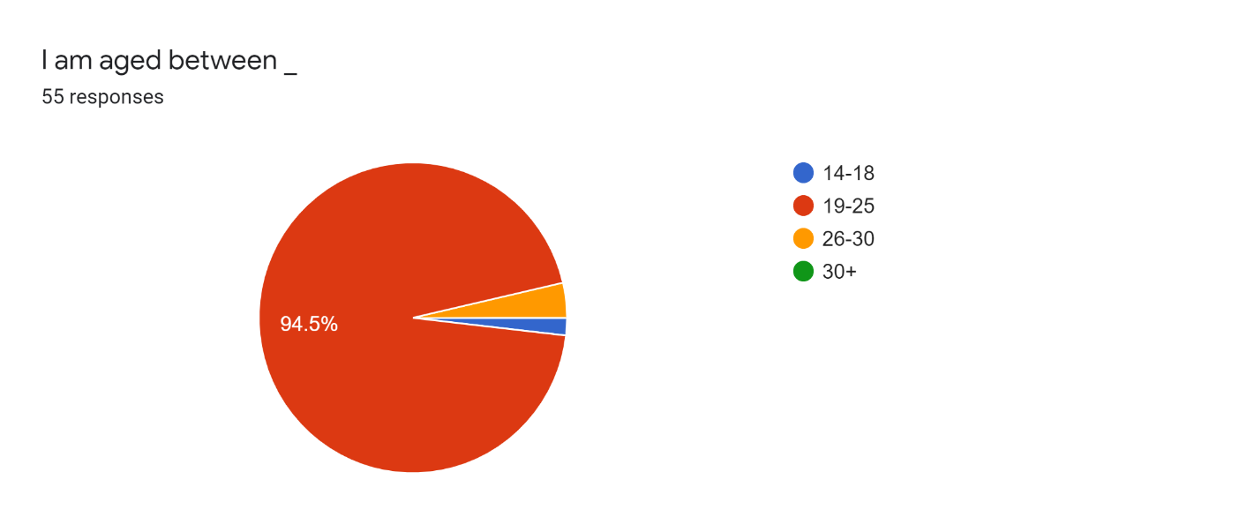

We're attempting to determine which age groups are interested in our website. People between the ages of 19 and 25 appear to be the most interested, followed by those under the age of 25.

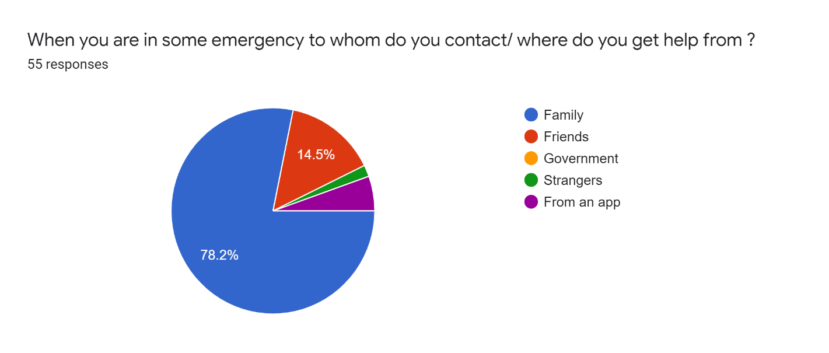

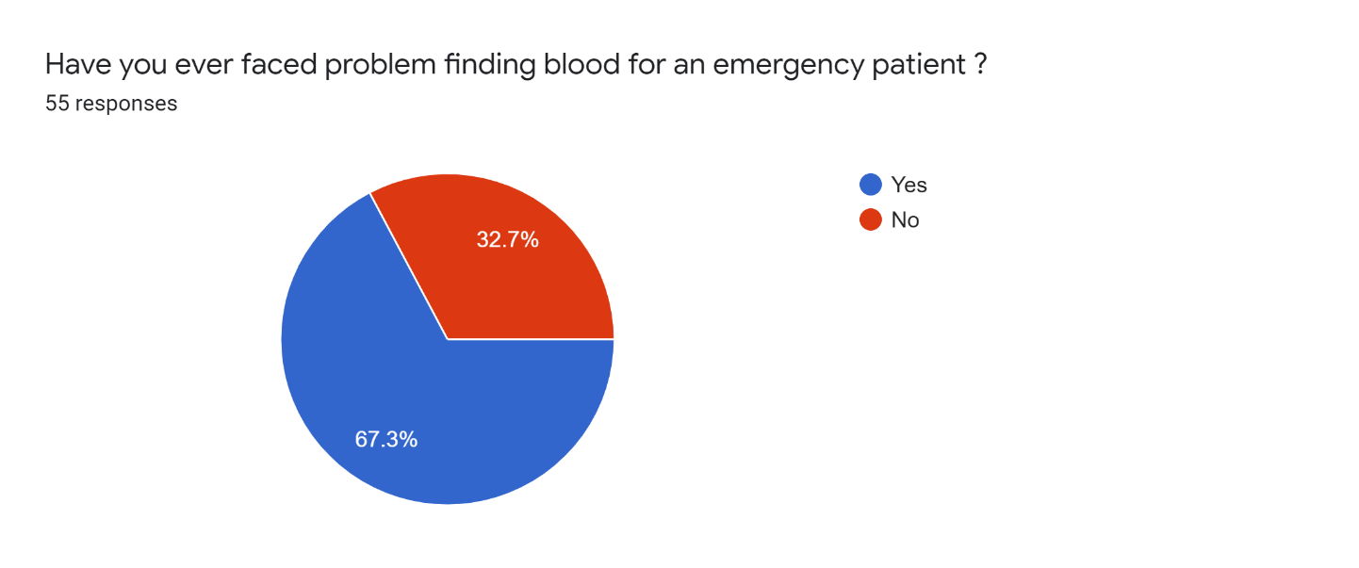

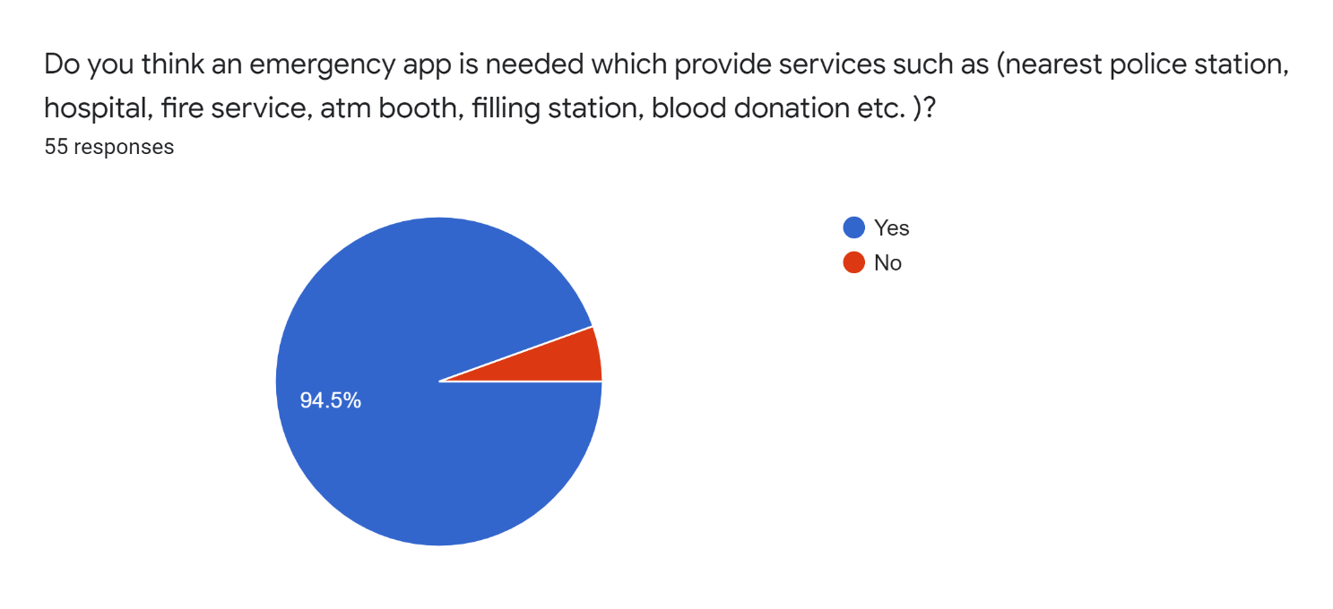

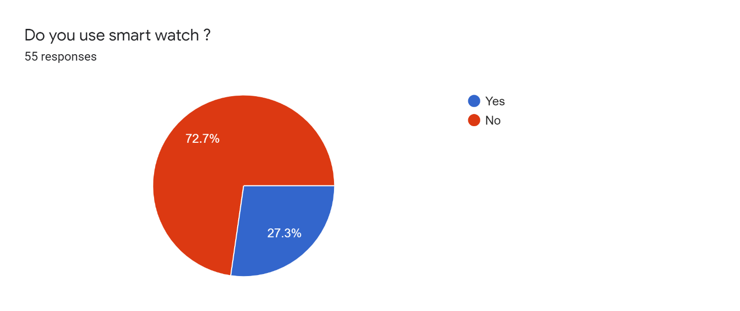

**2. Planning**

**Gantt Chart**

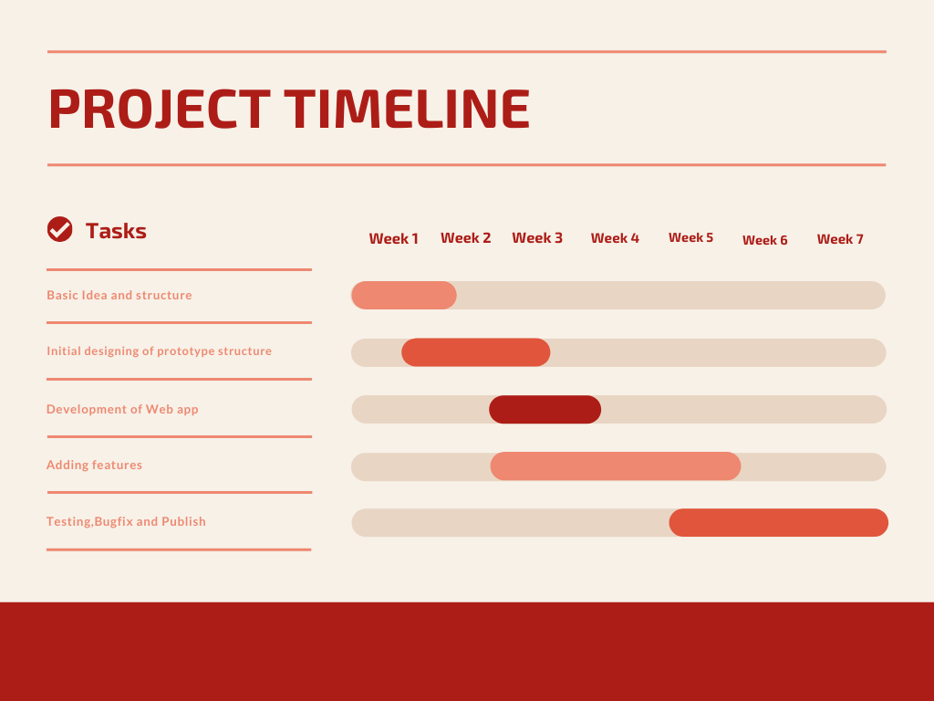

**Project Planning**

We have planned our project with five processes. Those area given below:

1. We will have full basic idea of project and structures within 1 week.
2. Then initial design for the project structure in between week 1 to week 3
3. Then the development of the project will be starting from end of the week 2 to week 6
4. Then features addition will be completed between end of the week 2 to middle of the week 6
5. Then end of the 5th week to final 7th week we will be fixing bugs and then submit the project.

**Project Estimation**

We plan to finish our project in 7 weeks as per lab timing. This project has a lot of area for improvement in the future. The risk about this project is to eliminate the threats that have been on other similar applications and websites also data safety of users. But we are making the best possible way to avoid this issue.

**Cost Benefit Analysis**

The cost of this project we initially find out that would be:

|  |  |
| --- | --- |
| Costs | In 12 Months (BDT) |
| Upload In Play Store | 5000 |
| Software Engineer | 100,000 (1 Month) |
| App Developer | 65,000 |
| Advertisement | 40,000 |
| Hidden Cost | 30,000 |
| Maintenance Cost | 50,000 |
| Total | **290,000** |

The cost of the project is based on our work time. We will be working 20 hours weekly. So based on it, the cost of this project is 290,000 Taka BDT in the starting year.

**Feasibility Study**

1. **Operational Feasibility**

* **Control:** The data of users will remain secured throughout this application; the risk of data loss will be minimized.
* **Efficiency:**
* Firebase database and Android Studio software will be used throughout this application, therefore the soft-wares will make sure the application performs efficiently.
* Maximum best output is provided to this application.
* **Services:**
* User can create an account to access all the features
* User can search for nearby Hospital, Police Station, Pharmacy, ATM Booth & Fuel Station when they need emergency

1. **Economical Feasibility**

We have drafted a break-even analysis temporarily.

|  |  |  |  |
| --- | --- | --- | --- |
| Year | Costs | Profit (BDT) | Net Profit (BDT) |
| 1st Year | 290,000 | 180,000 | -110,000 |
| 2nd Year | 290,000 | 320,000 | 30,000 |
| 3rd Year | 290,000 | 470,000 | 180,000 |

1. **Technical Feasibility**

* Assessing technical feasibility includes evaluating the ability of computer hardware and software to handle workloads adequately.
* Estimating Workloads and database or storage capacity.

1. **Legal Feasibility**

At this time, there are no potential legal or copyright difficulties with our project.

**Resource Requirements**

Resources we will need:

● 2 System Analyst and planner

● 3-5 Programmers

**3. Modeling:**

**Project Features**

* Hospital Service
* Police station Service
* Fire Service
* Pharmacy
* ATM Booth
* Fuel Station
* Location Sending to Emergency Contact
* Blood bank

**Function Definitions**

**Function Descriptions:**

|  |  |
| --- | --- |
| Function Name | Hospital |
| Description | In this location-based system, our app will use GPS to detect persons live location. Users can find near-by hospitals in any emergency situation |
| Precondition | None or Login |

|  |  |
| --- | --- |
| Function Name | Pharmacy |
| Description | In this location-based system, our app will use GPS to detect persons live location. Users can find near-by pharmacies from anywhere |
| Precondition | None or Login |

|  |  |
| --- | --- |
| Function Name | ATM Booth |
| Description | In this location-based system, our app will use GPS to detect persons live location. Users can find the nearest location of their desired ATM booths |
| Precondition | None or Login |

|  |  |
| --- | --- |
| Function Name | Police Station |
| Description | In this location-based system, our app will use GPS to detect persons live location. Users can contact any near-by police station for any emergency need |
| Precondition | None or Login |

|  |  |
| --- | --- |
| Function Name | Fuel Station |
| Description | In this location-based system, our app will use GPS to detect persons live location. Users can search for the nearest location of fuel stations |
| Precondition | None or Login |

|  |  |
| --- | --- |
| Function Name | Call 999 |
| Description | If the user doesn’t have an active internet connection, then he/she can use government emergency helpline service 999 |
| Precondition | None |

|  |  |
| --- | --- |
| Function Name | Blood Bank |
| Description | User can locate blood donor according to his need |
| Precondition | Login |

**Architecture Flow Diagram**

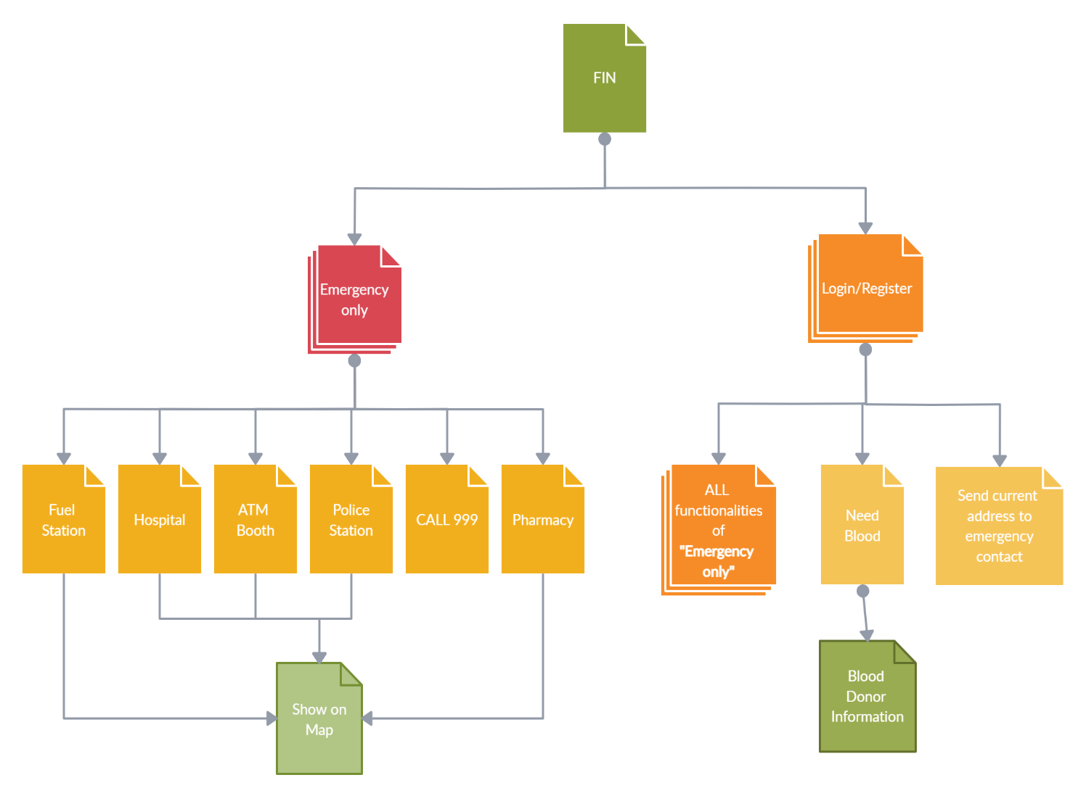

**4. Construction**

**Development Environment**

1. **Framework:** Android Studio
2. **Language:** Java
3. **Database:** Firebase

**5. Conclusion**

To Conclude, FIN will be our useful friend during emergency time. Our safety will be at our fingertips. Hopefully, our life will be safer than ever.

**6. Bibliography / References:**

* [Yours for the making - Instructables](https://www.instructables.com/)
* [Big Think - Smarter, Faster](https://bigthink.com/)
* [Goodreads | Meet your next favorite book](https://www.goodreads.com/)

**Appendix**

* I would define myself as _
* I am aged between _
* When you are in some emergency to whom do you contact / Where do you get help form?
* Have you ever faced problem finding blood for an emergency patient?
* Do you think an emergency app is needed which provide services such as (nearest police station, hospital, fire service, atm booth, filling station, blood donation etc.)?
* Do you use smart watch?